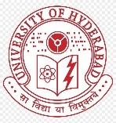 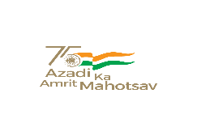 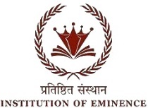

**BHARAT KA AMRIT MAHOTSAV**

UNIVERSITY OF HYDERABAD

SCHOOL OF COMPUTER AND INFORMATION SCIENCE

Collaboration with O/o Dean Student Welfare & O/o Chief Warden

Cordially invites you to Industrial Interactive and Valedictory Session of Two days National Seminar on “BAM-2022“

Organized on 7th & 8th April 2022

Industrial Interactive & Valedictory Session

**8th****April 2:00 pm to 6:30 pm Venue:** **Zakir Hussain Lecture Hall, S6**

|  |  |  |
| --- | --- | --- |
| Industrial Interactive Session | Chennapa Naidu DarapaneniCEO of MeraEventDr. Raghavendra KuneScientist SG Head for HPCDS, ISRO | 2:00 – 2:45 |
| **Welcoming Guests** | Prof. G. Nagaraju  Dean Student Welfare | 2:50 – 3:00 |
| **Reporters Report** | Ms. Srijita Majumdar &  Mr. R. Pandurang Yashasvi | 3:10 – 3:20 |
| **Chief Guest** | Prof. Bayya Yegnanarayana Adjunct Faculty, IIT Trupati | 3:20 – 3:30 |
| **Guest of Honour** | Prof. Ramella  ISRO, Banglore  V.V. Lakshminarayan  Former IPS  Dr. Madhusudhan Singh  Woosong University | 3:30 – 3:40 |
| **Special Invitees** | Prof. Kavi Narayan Murthy  SCIS, UOH  Prof. Darla Venkateswara Rao  Head of the Telugu Department  Prof. JSR Prasad  Head of Sanskrit  Associative Director CIS | 3:40 – 3:50  4:00 – 4:10  4:10 – 4:20 |
| TEA BREAK | | |
| **Plenary Speech** | Dr. Dimple Kaur | 5.30 – 6.00 |
| **Vote of Thanks** | Dr. M. Muthamilarasan  Assistant Professor, SLS  Warden, MH-K | 6:00 – 6:30 |